F.18 -

Functionality
This function allows you to generate letters to your vendors for the purpose of checking payables and receivables, as well as the necessary reply slips. The program offers you the following choice of procedures:
- balance confirmation
- balance notification
- balance request
The system generates one checklist and, where necessary, one error list per company code. You also have the option of requesting a results table. For each program run, a selection cover sheet can be output. The program also enables you to print reminders for overdue balance confirmations and balance requests. In order to do this, enter the vendors concerned and the old issue date and/or the old reply date.
Before the program can be run, the requirements described in the following sections must be fulfilled. This includes the entries that have to be made via the system configuration and the forms to be used for printing the letters and lists.

Scenario
Before year-end closing you want to receive confirmation of open items and balances from your vendors.

Requirements
Before the program can be run, the system must be properly configured. This includes the entries that have to be made via the system configuration and the forms to be used for printing the letters and lists.

Menu Path | Accounting → Financial Accounting → Accounts Payable → Periodic processing → Print correspondence → Balance confirmation → F.18 - Print letters
Transaction Code | F.18

Vendor Balance Confirmation

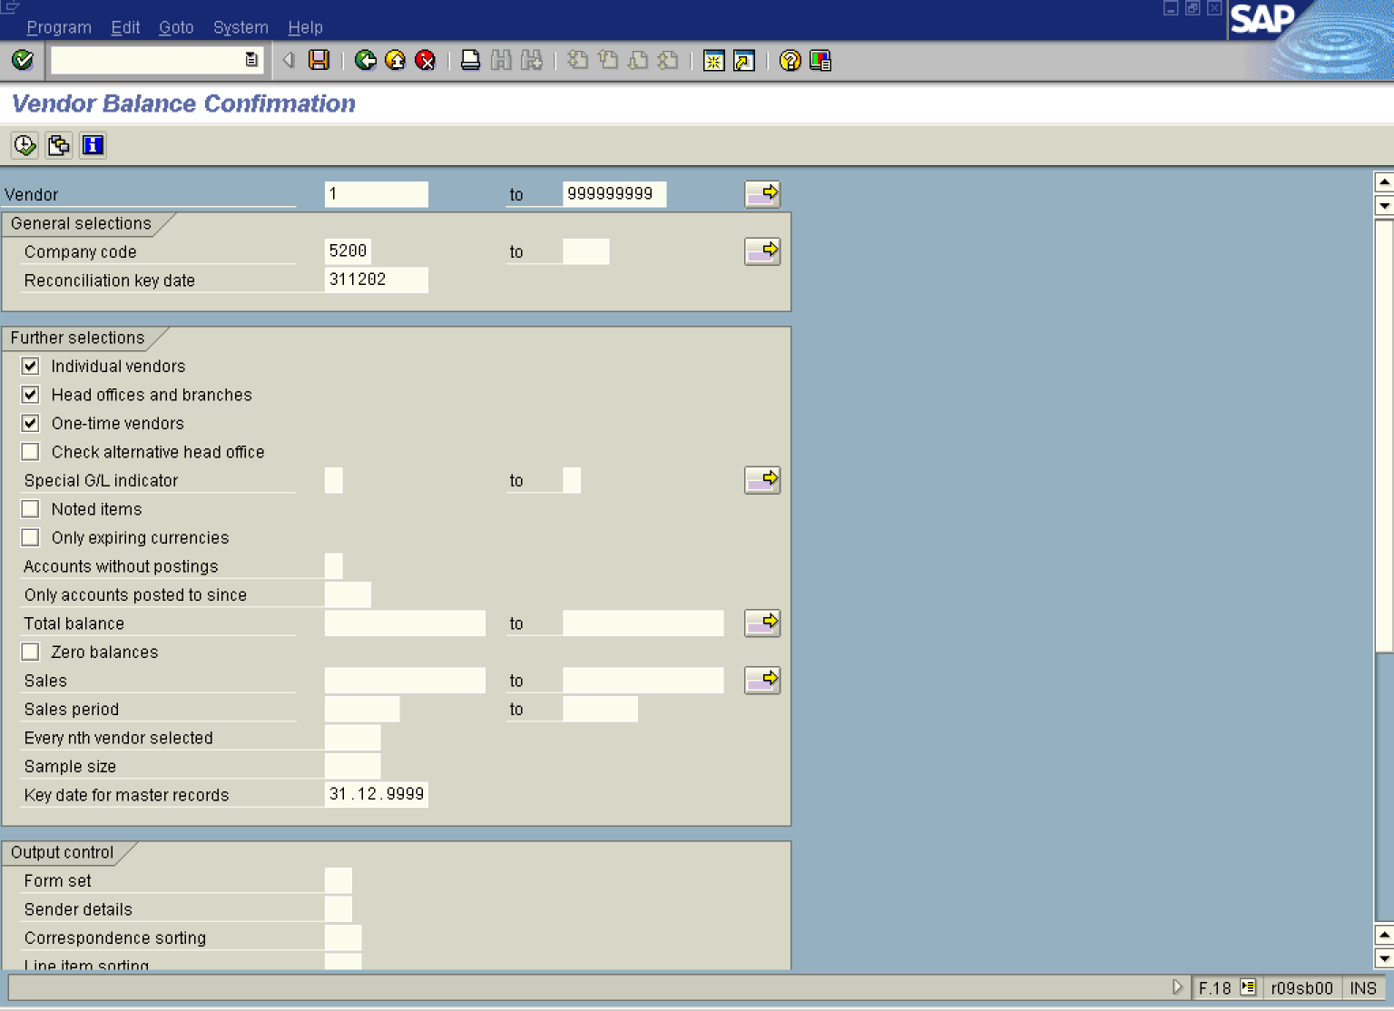

1. Update the following fields:

Field Name | Field Description | Values
Vendor | Vendor account number | Example: 1
to | Vendor account number | Example: 999999999
Company code | Code identifying a separate legal entity for which a separate set of accounts is maintained for external reporting purposes | Example: 5200
Reconciliation key date | Date of the balance confirmation. Usually enter here the last day of the fiscal year. | Example: 311202

2. Click Individual vendors Button to include vendors in the printout.

3. Click Head offices and branches . In this case the system will prepare the balance confirmations for the head offices The open items belonging to the branche will be included in the report for head office.
4. Click One-time vendors to process also this data.
5. Click Zero balances Button to not print the letters for vendors with zero balance.

6. Scroll down the screen and enter additional data:

Vendor Balance Confirmation

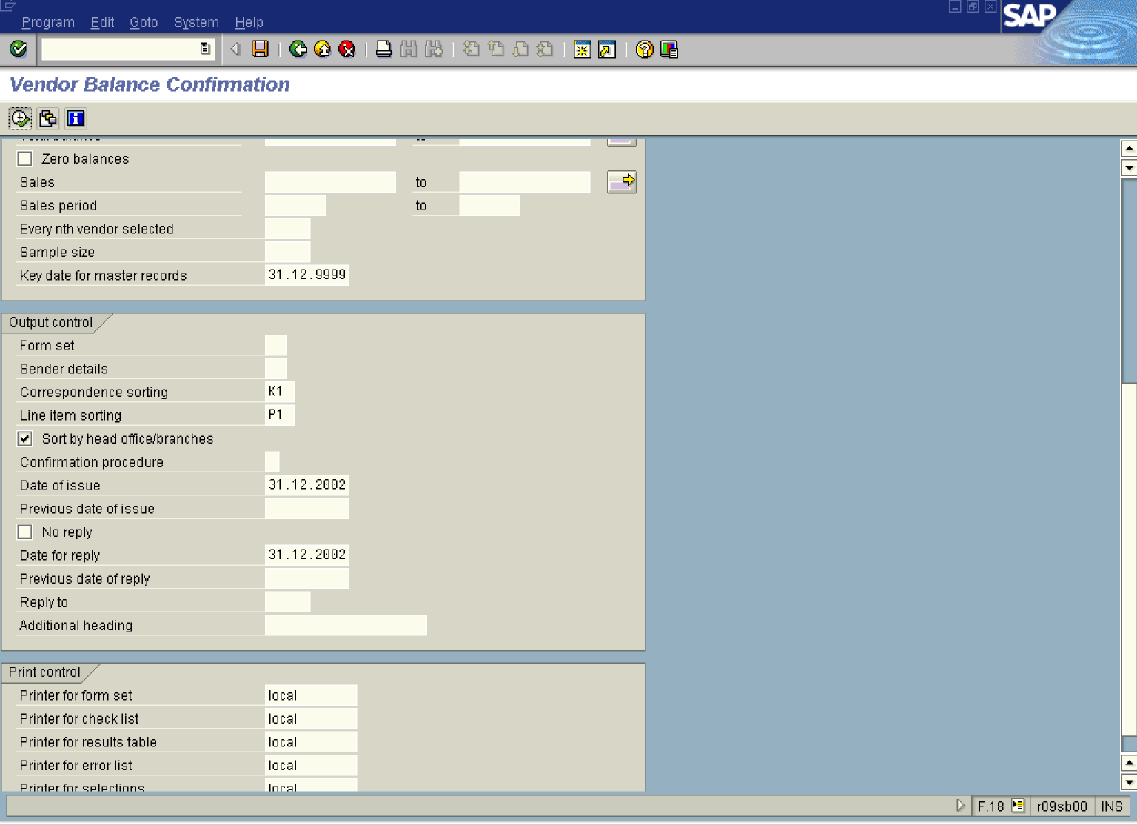

7. Update the following fields:

Field Name | Field Description | Values
Correspondence sorting | You can sort the letters by postal code, by account number or by document number | Example: K1
Line item sorting | You can sort open items on the report by e.g. document date, or clearing date, clearing document etc. | Example: P1
Date of issue | Enter here the date when the letters were issued | Example: 31.12.2002
Date for reply | The date is printed in the letter to the customer and vendor. | Example: 311202
Printer for form set | In this field and other fields for printout enter your printer name | Example: local

8. Click Sort by head office/branches Button to activate sorting line items by Head Office and Branch Accounts
9. Click Enter Button to confirm your entries.
10. To begin generation of vendor letters, Click Execute .

Note: This reports creates automatically print preview. On the following screens you should press Print icon to send a print request to the spool.

Print Preview for LOCA Page 00001 of 00047

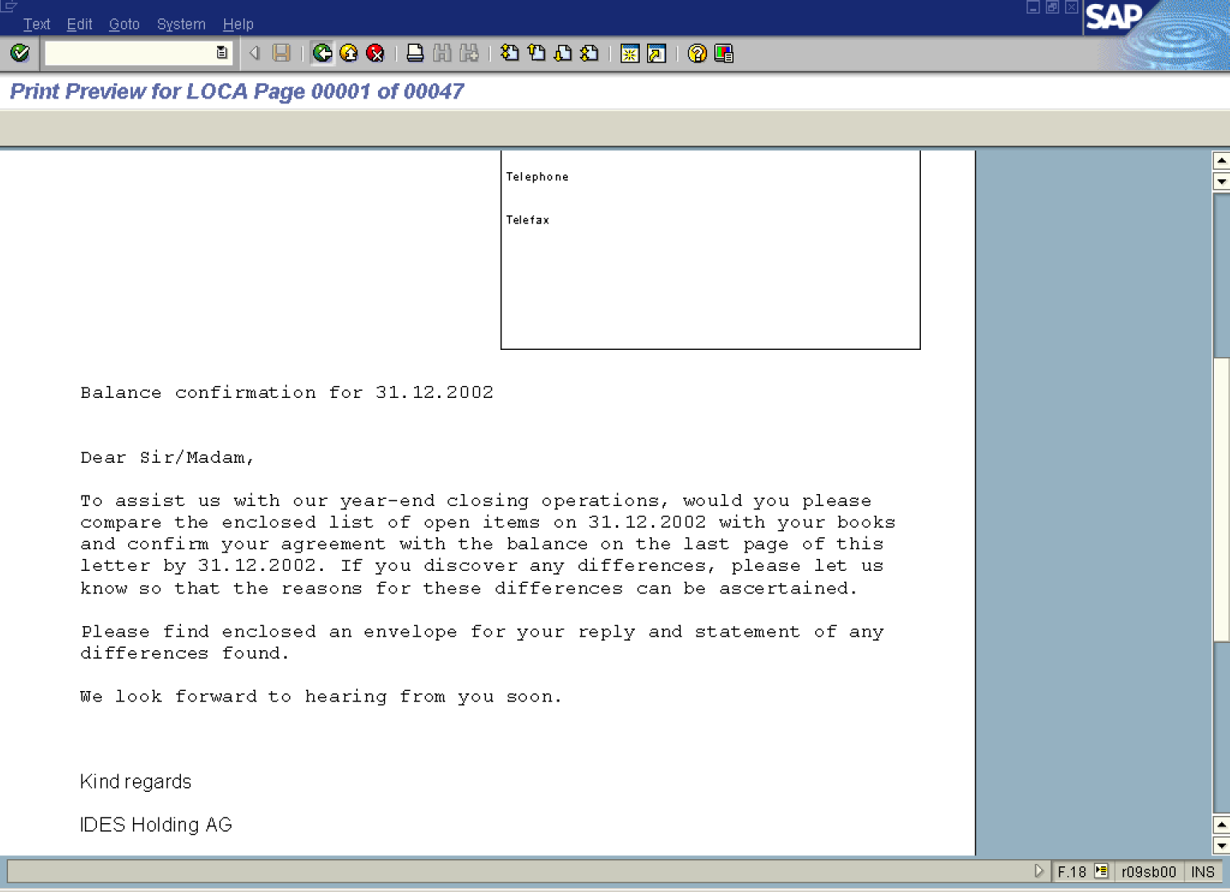

11. Click Print to send a print request to the spool.

12. Click Back .

Print Preview for LOCA Page 00001 of 00002

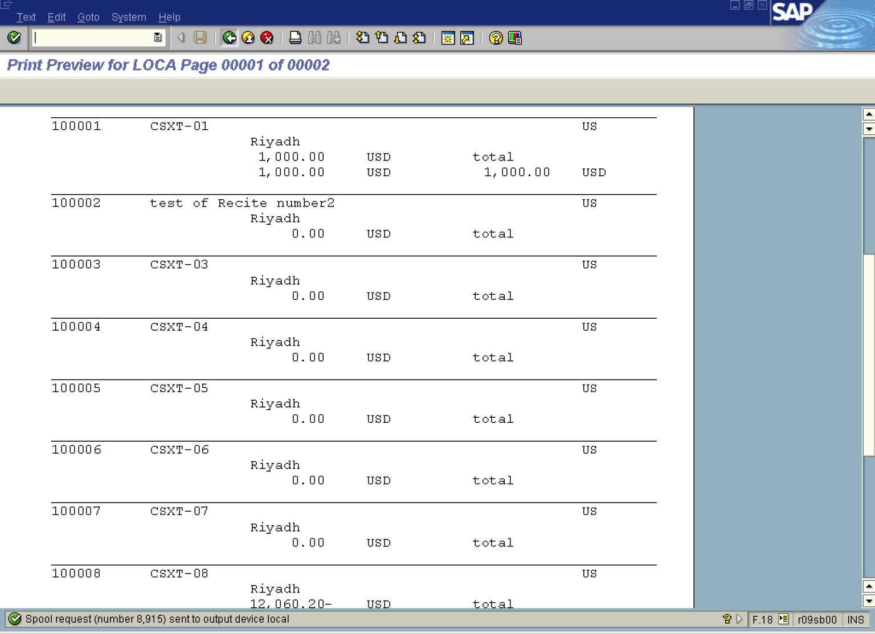

13. This is the report of the vendors for whom confirmation letters were generated. Click Print to send a print request to the spool.

14. Click Back .

Print Preview for LOCA Page 00001 of 00003

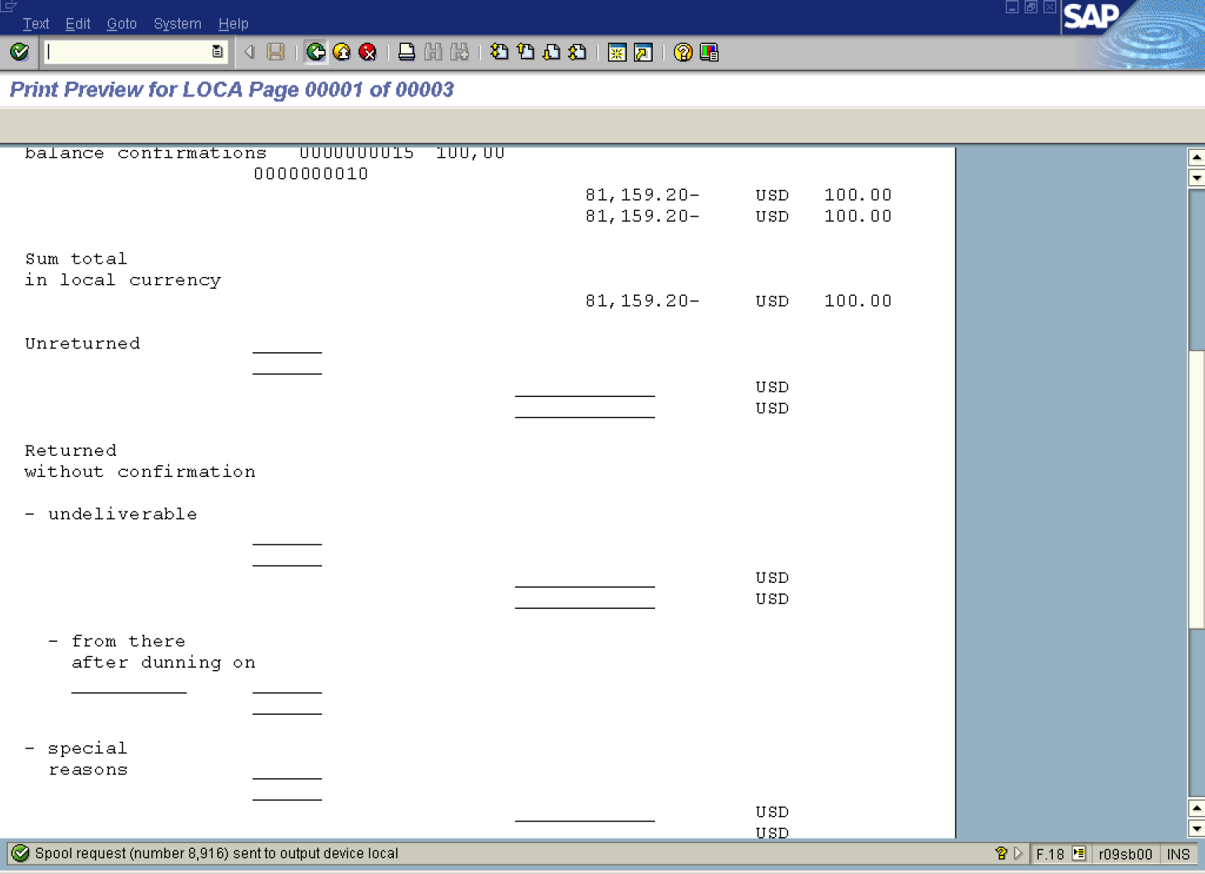

15. The last report displays total amount of vendor confirmations generated. Click Print to send a print request to the spool.

16. Click Back Button .

Note: The confirmation letters were not printed. They wait for printout in the spool. You need to display your spool jobs.

17. Change command line to [/nsp02] and press Enter. The system will display a list of print jobs:

Output Controller: List of Spool Requests

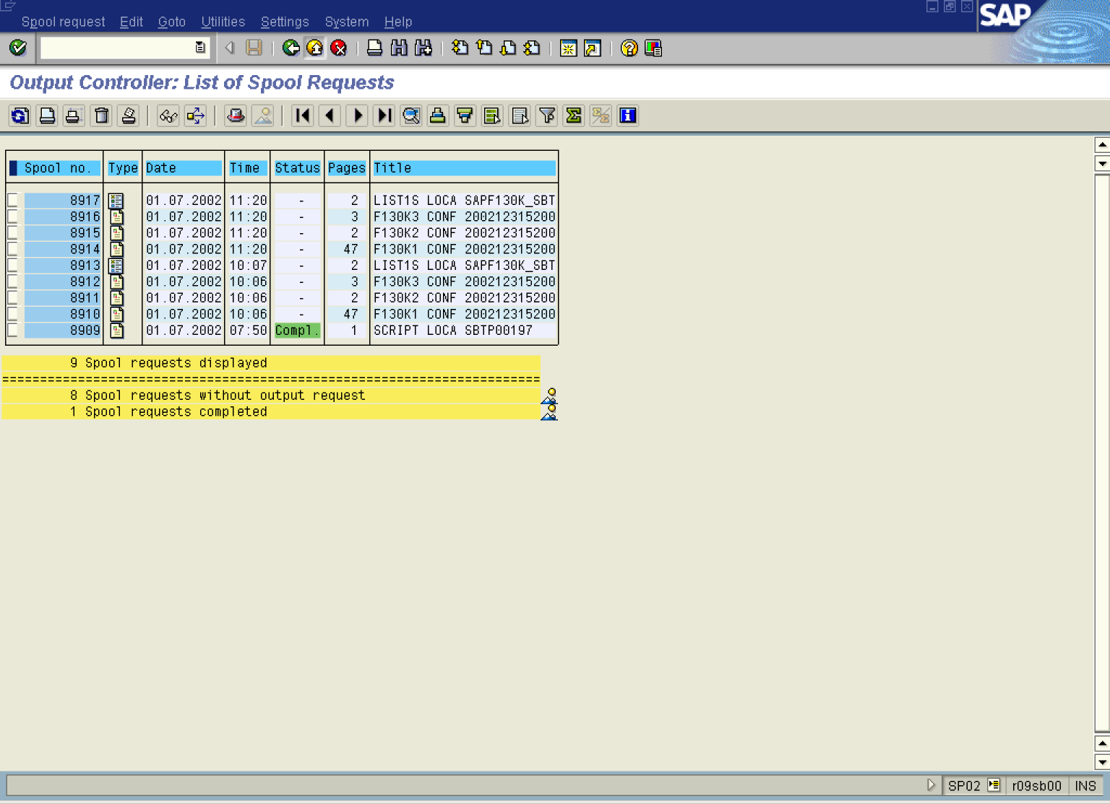

18. To activate the job for printout mark it (click on the first column on the left) and click on the Print button.

